
MATHEMATICS DEPARTMENT
Year 12 Methods - Test Number 3 - 2016
Integration and the Binomial Distribution
Resource Free

Name: _______________________________________ Teacher: __________________
Marks: 21
Time Allowed: 15 minutes
Instructions: You are NOT allowed ANY Calculators or notes.
You have been supplied with a formula sheet.
_________________________________________________________________________
1 Which statement is not true?
A
B
C
D
E [2 marks]
2 An approximation to using 10 centred rectangles is given by:
A 0.2 × [03 + 0.23 + 0.43 + 0.63 + 0.83 + 13 + 1.23 + 1.43 + 1.63 + 1.83]
B 0.2 × [0.23 + 0.43 + 0.63 + 0.83 + 13 + 1.23 + 1.43 + 1.63 + 1.83 + 23]
C 0.1 ×[0.13 + 0.33 + 0.53 + 0.73 + 0.93 + 1.13 + 1.33 + 1.53 + 1.73 + 1.93]
D 0.2 ×[0.13 + 0.33 + 0.53 + 0.73 + 0.93 + 1.13 + 1.33 + 1.53 + 1.73 + 1.93]
E 0.2 × [0.253 + 0.53 + 0.753 + 13 + 1.253 + 1.53 + 1.753 + 23]
[2 marks]

3 The area of the figure below is given by:
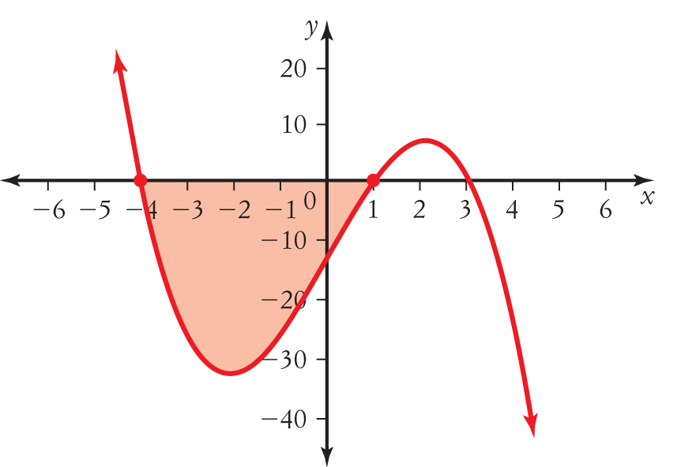
A
B
C
D
E [2 marks]
4 Which statement would find the approximate area under the curve y = 4 - x2 using the rectangles below.
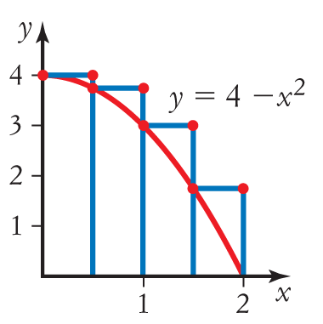
A 0.5 × [4 – 02 + 4 – 0.52 + 4 – 12 + 4 – 1.52]
B 0.5 × [02 + 0.52 + 12 + 1.52]
C 0.5 × [0.52 – 4 + 12 – 4 + 1.52 – 4 + 22 – 4]
D 0.5 × [4 – 0.52 + 12 + 1.52 + 22]
E 0.5 × [4 – 0.52 + 4 – 12 + 4 – 1.52 + 4 – 22] [2 marks]
5 The value of the definite integral is:
A –
B
C
D
E –
[2 marks]
6 =
A
B
C 5f ′(x) + 3
D
E [2 marks]
7 The shaded area below can be written as:
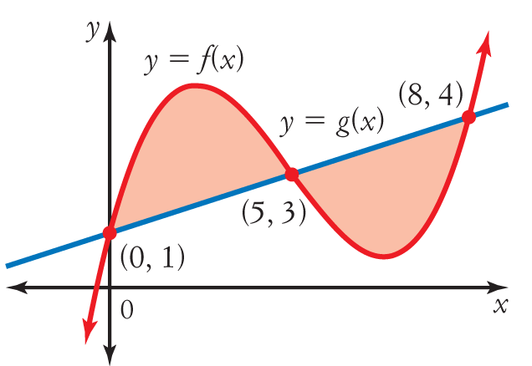

A
B
C
D
E [2 marks]
8 =

A 64
B 48
C 40
D 24
E 12 [2 marks]

9 If the derivative of is 2(x − 3) , then the antiderivative of (x − 3) is:
A + c
B (x − 3)
C + c
D 2(x − 3)
E + c [2 marks]

- Find the exact probability that when a six-sided die is rolled four times a number less than 5 occurs on exactly two occasions.

[3 marks]

Additional Working Space Below:

***END OF RF TEST***

